# OS Worksheet 3: PintOS

Worksheet 3 was to implement a Pintos, execute make, create a file sys and to fix bugs.

## Forking the PintOS project and cloning

The source code were obtained from the link provided in the worksheet (<https://gitlab.uwe.ac.uk/s23-li/Pintos>). I created a copy of the source code to my Gitlab workspace, and then cloned the repository to local system to start working on it.

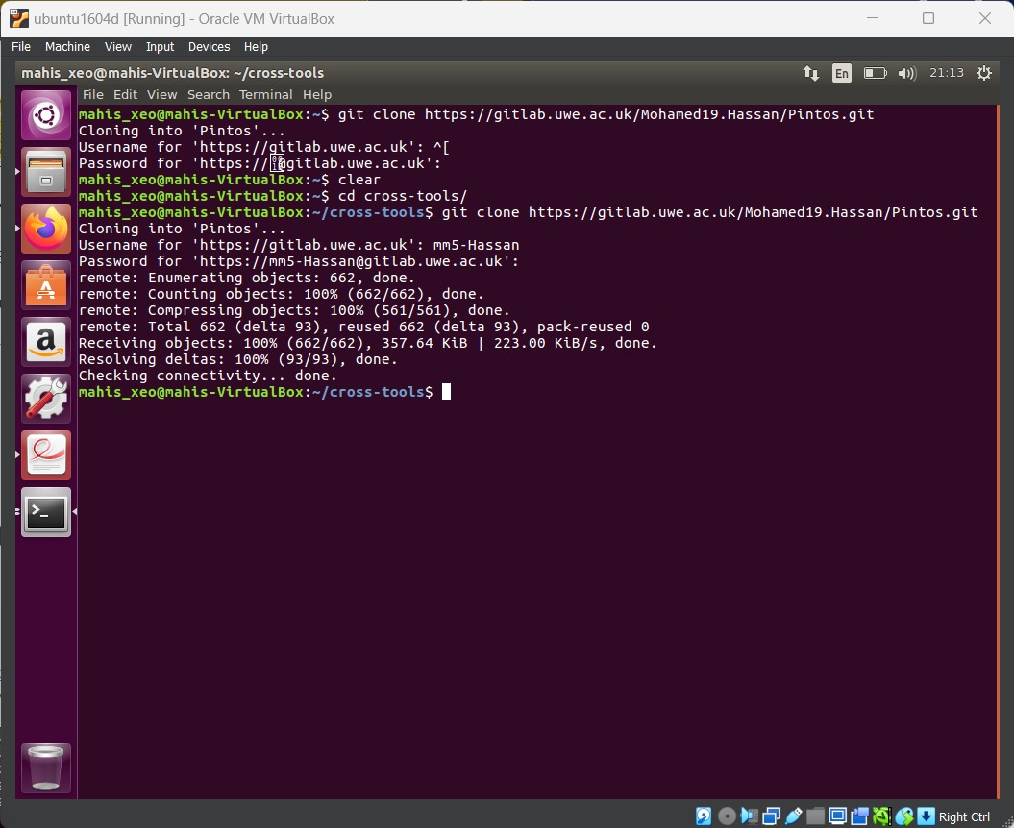

## Setting up Path and executing make command

* As I was cloning to existing cross-tools folder which was used for worksheet 2, below paths were added

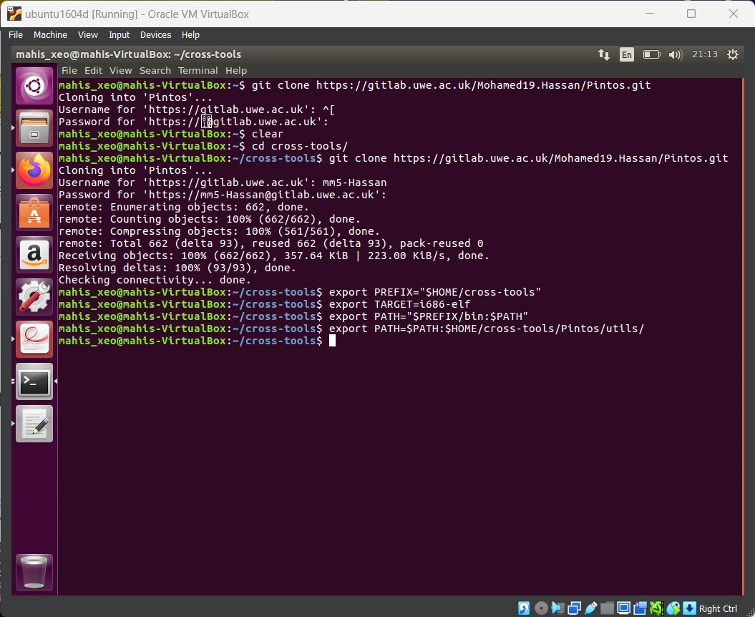

* Next make function were run for in 3 directories; examples, threads and userprog

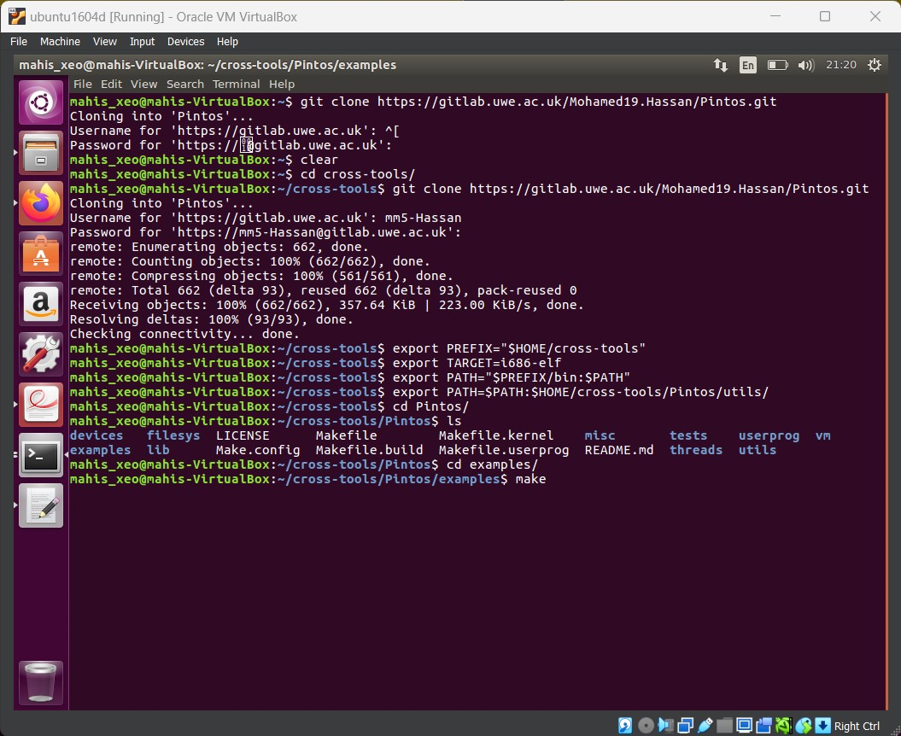

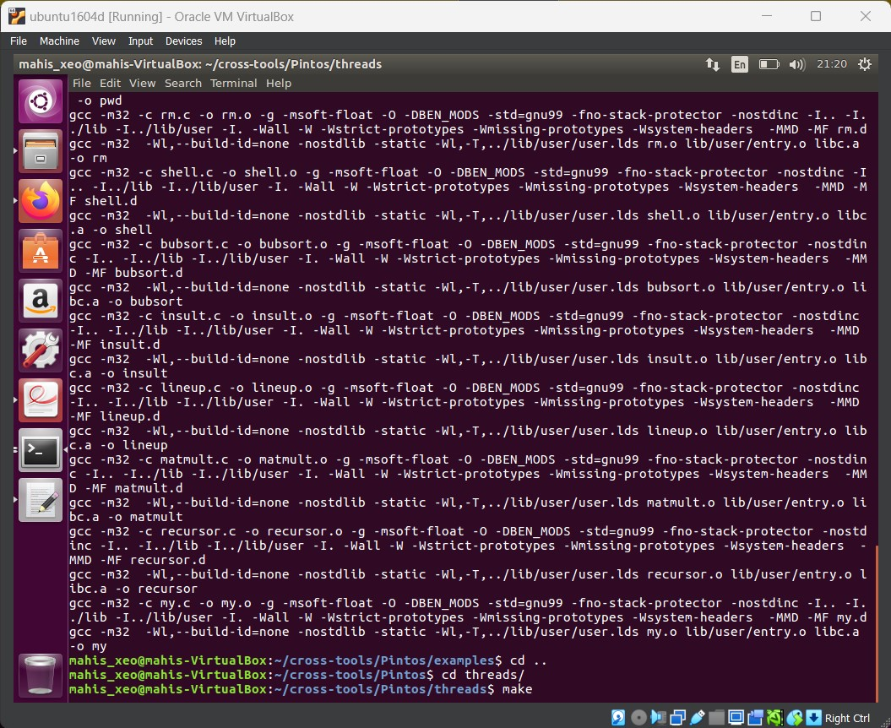

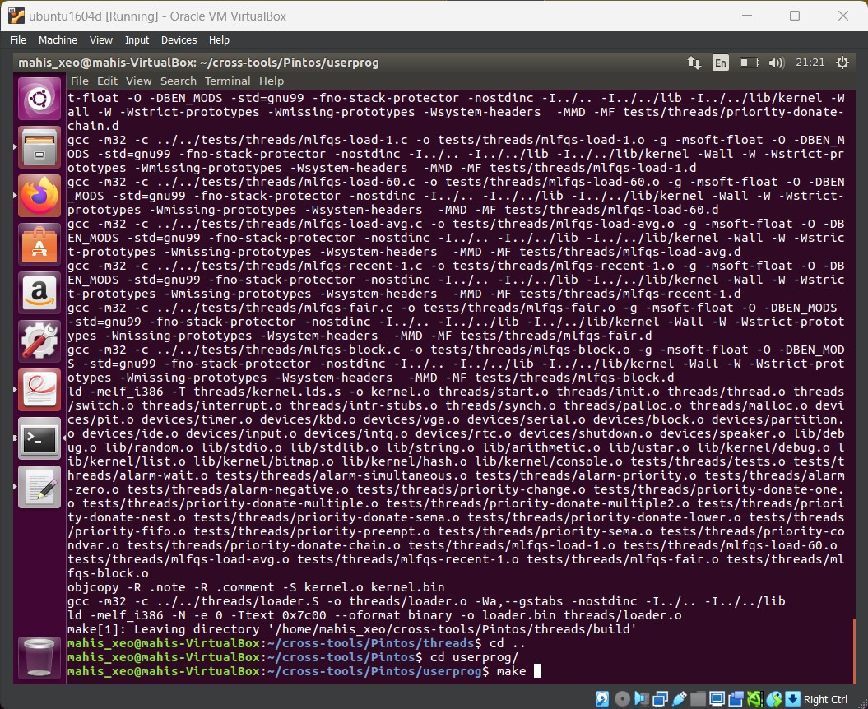

* Next we changed directories to Pintos/userprog/build/ to create the file system and to format the system

## 

## Running Test and updating source code

* Run ‘Pintos run alarm-multiple’

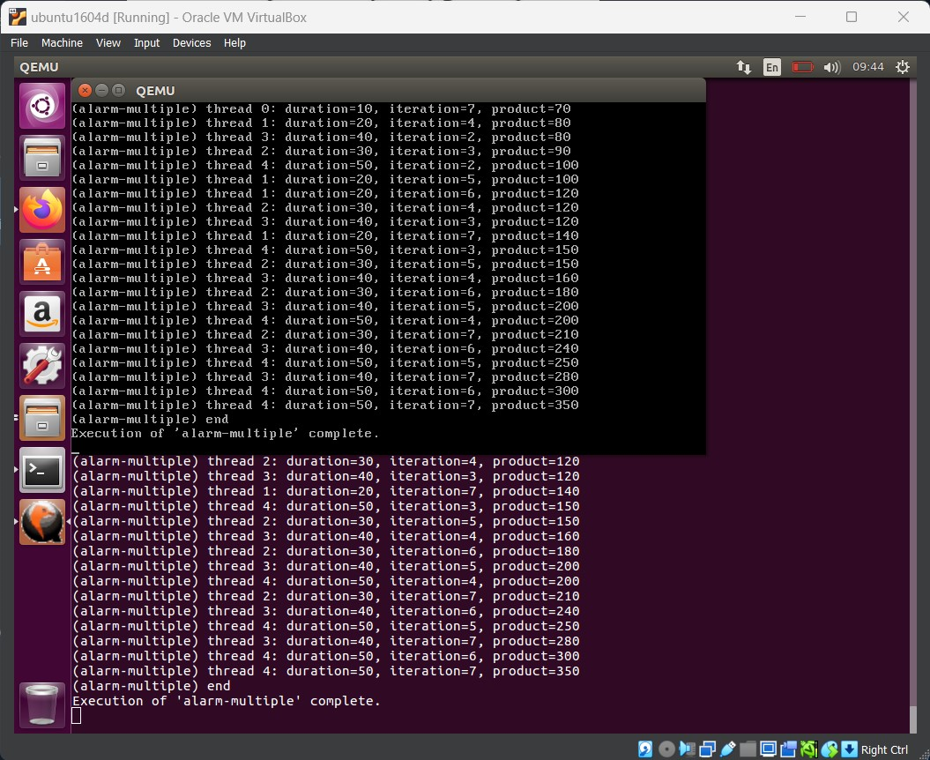

* Code Changes Process.c in userprog
  + Updates *esp = PHYS_BASE to avoid page fault

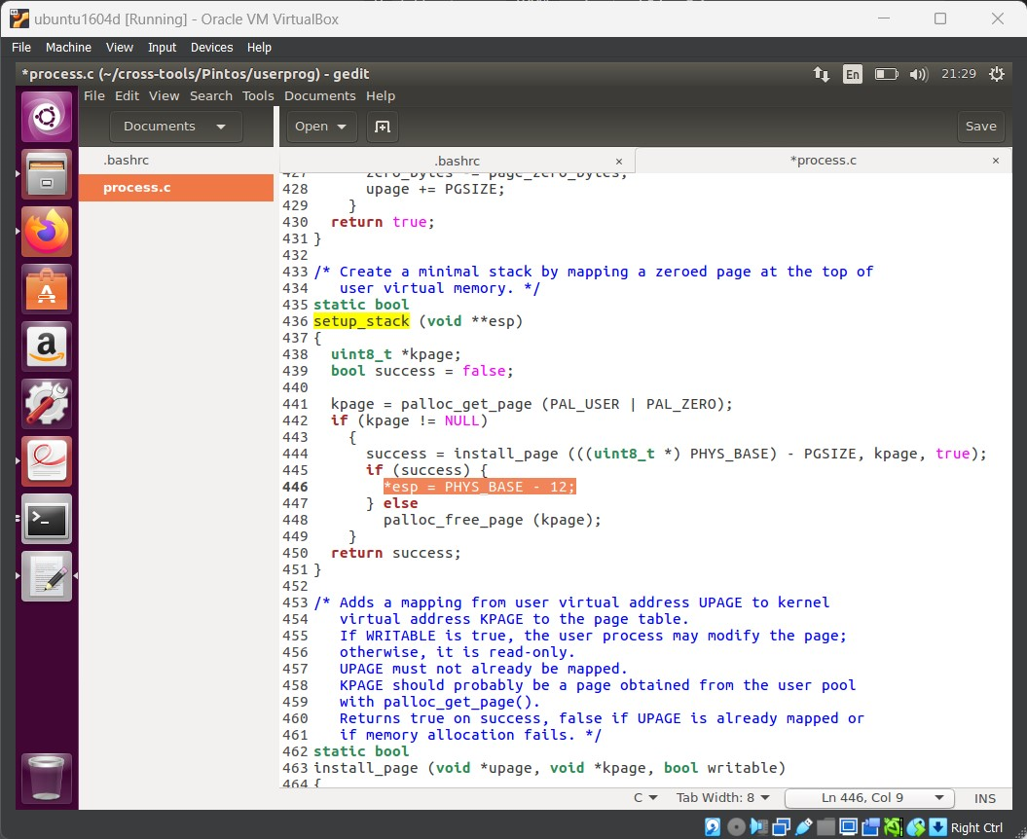

* + Added code to extract program name in start_process and process_execute

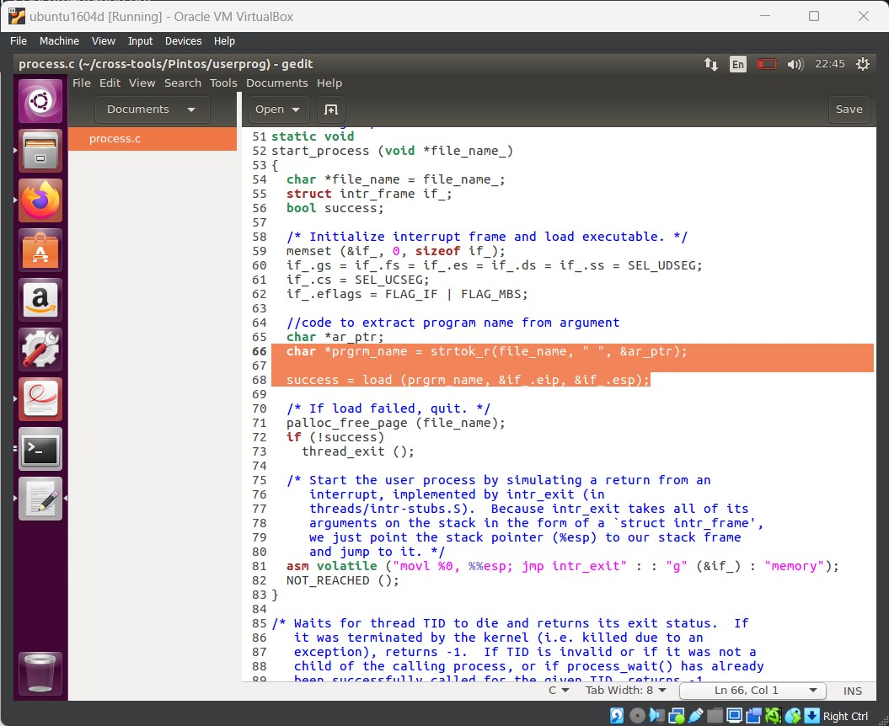

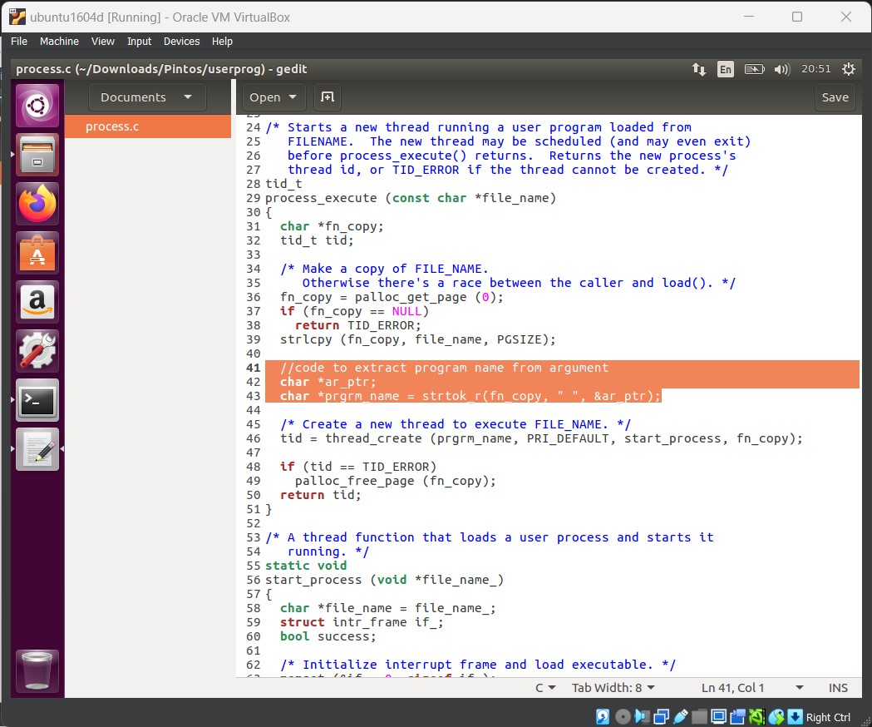

* + Implementation of exit code in process_exit

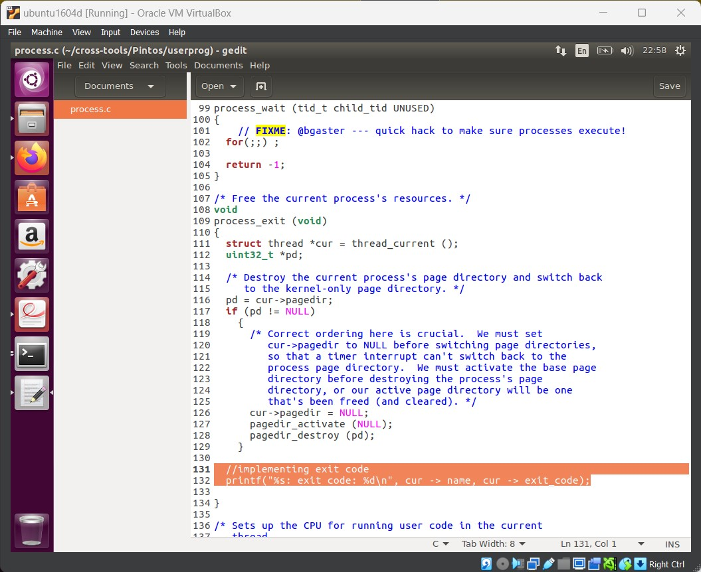

* Code changes to thread.h in threads directory
  + Implementation of exit code in thread.h

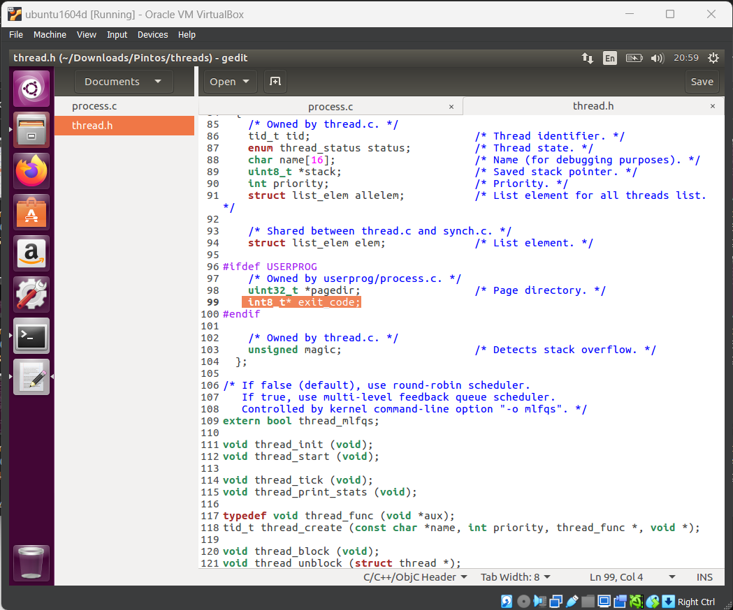

## Running ‘Echo x’

* Run “pintos -p ../../examples/echo -a echo -- -q” in userprogs/build

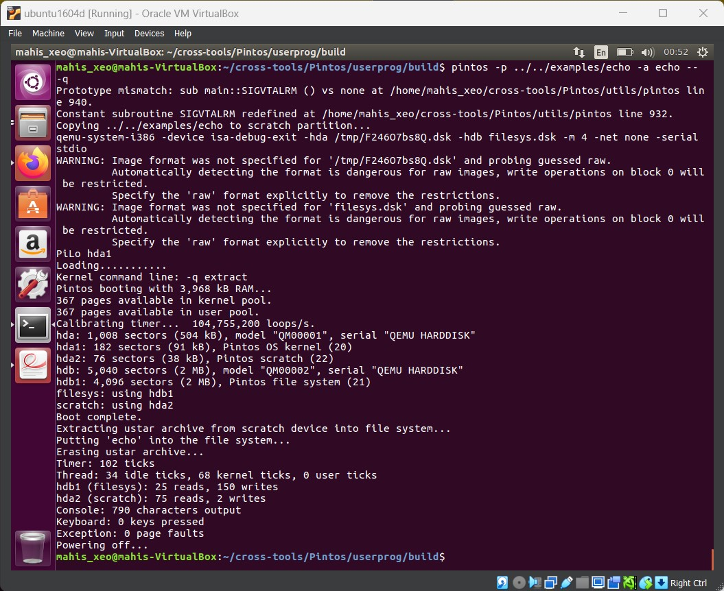

* Running “pintos -q run 'echo x'”

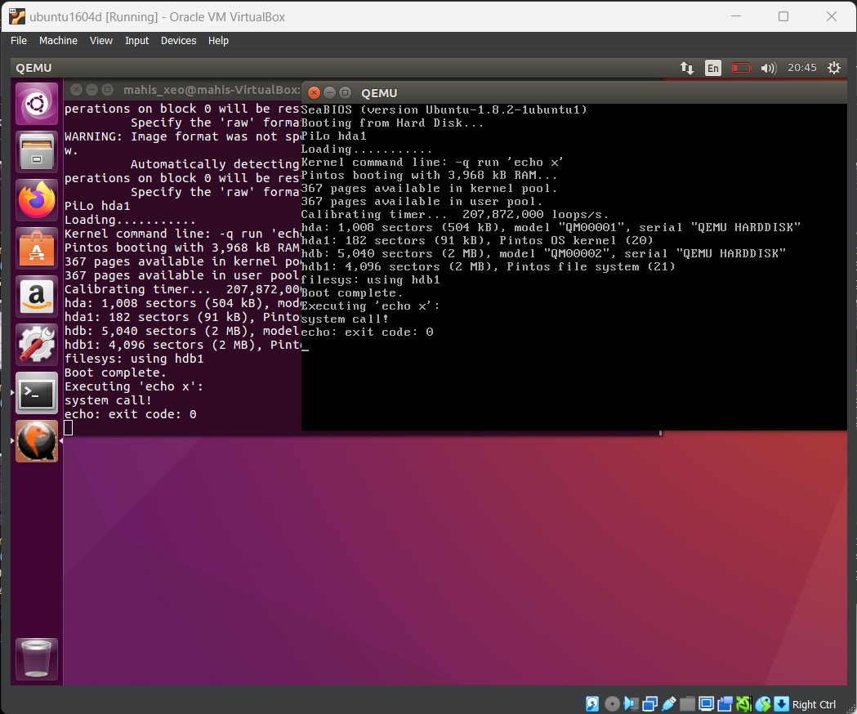

* Git pushed to <https://gitlab.uwe.ac.uk/Mohamed19.Hassan/Pintos>